**Kumbh mela**

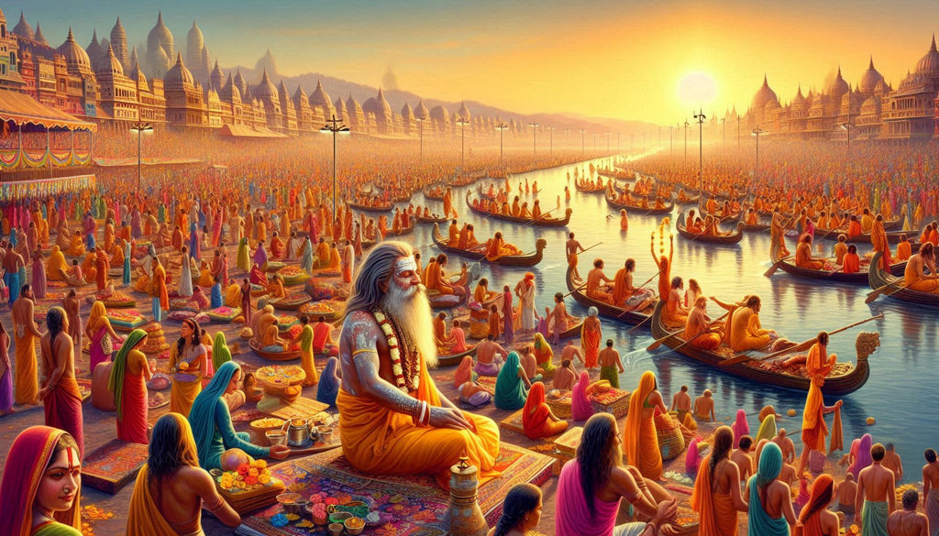

The **Kumbh Mela** is one of the largest and most significant religious gatherings in the world. It is a Hindu festival that occurs every 12 years at four different locations in India: **Prayagraj (Allahabad), Haridwar, Nashik, and Ujjain**. The event is centered around bathing in sacred rivers, such as the Ganges, Yamuna, Godavari, or Shipra, to wash away sins and gain spiritual merit.

The **Kumbh Mela** occurs at four main locations in India, each associated with a specific astrological alignment, and it is celebrated in different forms.

**There are four types of Kumbh Mela**

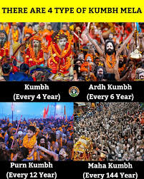

### 1. ****Purna Kumbh Mela****:

* **Frequency**: Every 12 years.
* **Locations**: It rotates between the four sacred locations — **Prayagraj (Allahabad), Haridwar, Nashik, and Ujjain**.
* **Significance**: This is the largest and most significant of all the Kumbh Melas. It is marked by a complete planetary alignment that makes it the most spiritually potent time for the event. A Purna Kumbh Mela is celebrated when the alignment of the planets is especially favorable, bringing immense spiritual merit to those who take part in it.

### 2. ****Ardh Kumbh Mela****:

* **Frequency**: Every 6 years.
* **Locations**: The Ardh Kumbh Mela is celebrated at **Prayagraj (Allahabad)**.
* **Significance**: "Ardh" means half, and this version of the Kumbh Mela takes place when the alignment of the stars and planets is not as intense as it is for the Purna Kumbh Mela but still holds great significance. It is considered a major pilgrimage, though on a slightly smaller scale than the full Purna Kumbh Mela.

### 3. ****Magh Mela****:

* **Frequency**: Annually.
* **Locations**: Held at **Prayagraj** during the month of **Magh** (the 11th month of the Hindu calendar, usually corresponding to January-February).
* **Significance**: While not a full Kumbh, the Magh Mela attracts millions of pilgrims every year. It is held in conjunction with the period of the **Makar Sankranti** festival, and although it does not have the grand scale of a Kumbh Mela, it still carries a deep spiritual significance, with devotees bathing in the Sangam (confluence of the Ganges and Yamuna).

### 4. ****Kumbh Mela**** (Regular/Other Kumbhs):

* **Frequency**: Every 12 years (but not at the same scale as Purna Kumbh Mela).
* **Locations**: **Nashik**, **Ujjain**, **Haridwar**, and **Prayagraj** are the four designated places where the Kumbh is held. Each location has its own distinct timing and significance, linked to the positioning of celestial bodies.

#### Additional Notes:

* **Prayagraj** (Allahabad) is the place where the **Purna Kumbh** is most prominently held, and it's the site of the largest gathering of pilgrims. The **Maha Kumbh Mela** is considered a special event that happens once every 144 years at Prayagraj.
* The festival's importance is centered around bathing in the sacred rivers (Ganges, Yamuna, Godavari, or Shipra), offering purification of sins, spiritual renewal, and divine blessings.

Each type of Kumbh Mela carries a deep sense of devotion and attracts millions of people, showcasing the spiritual and cultural vitality of Hinduism.

**history**

The **Kumbh Mela** is one of the largest religious and cultural gatherings in the world, held periodically in India. It has profound significance in Hinduism, attracting millions of devotees from around the globe. Here's an overview of its history:

### ****Mythological Origins:****

The Kumbh Mela has roots in ancient Hindu mythology, particularly the story of the **Samudra Manthan** or the "Churning of the Ocean." According to the myth, the gods and demons churned the ocean to obtain the nectar of immortality (Amrita). During this process, a Kumbh (pot) filled with nectar surfaced. As the gods and demons fought over it, four drops of nectar fell at four locations: **Allahabad (Prayagraj), Haridwar, Ujjain, and Nashik**. These places became the primary locations where the Kumbh Mela is held, and it is believed that bathing in these rivers during the Mela can purify one's soul.

### ****Historical Evolution:****

The Kumbh Mela's origins are believed to date back over 2,000 years, possibly beginning around the time of the **Maurya Dynasty (circa 3rd century BCE)**. It was initially a small gathering for spiritual practices and ritual bathing in sacred rivers. Over time, it evolved into a grand festival that drew larger crowds, especially as it became associated with the ritual cleansing of sins and the acquisition of spiritual merit.

### ****Religious Significance:****

The Mela is dedicated to **Lord Shiva**, **Lord Vishnu**, and other deities of the Hindu pantheon. It is a time of immense spiritual fervor where pilgrims bathe in sacred rivers to wash away their sins and attain salvation (moksha). The event is also a platform for religious discourse, cultural activities, and religious performances by ascetics, sadhus, and yogis.

### ****Key Locations and Cycle:****

The Kumbh Mela is held at four major locations, each of which has a specific role in the festival:

1. **Allahabad (Prayagraj)** - The confluence of the Ganges, Yamuna, and the mythical Sarasvati River is considered the holiest site. The event is held here every 12 years.
2. **Haridwar** - Located on the banks of the Ganges River, the Kumbh Mela in Haridwar occurs once every 12 years.
3. **Ujjain** - Situated on the Shipra River, the Kumbh Mela in Ujjain happens once every 12 years.
4. **Nashik** - Held on the Godavari River, the Nashik Kumbh Mela is celebrated once every 12 years.

### ****Cycle and Time Period:****

The Kumbh Mela follows a **12-year cycle**, and each of the four cities hosts it once every 12 years. However, in between, a smaller version known as the **Ardh Kumbh Mela** (half Kumbh) is held at **Haridwar** and **Prayagraj** every six years.

The **Maha Kumbh Mela**, which is a grander, more significant gathering, is held at **Prayagraj** once every 144 years, drawing a larger crowd. The last Maha Kumbh was held in 2013, and the next one will occur in 2057.

### ****Rituals and Practices:****

1. **Holy Bath (Shahi Snan):** Pilgrims take a dip in the sacred rivers at the designated auspicious time to cleanse themselves spiritually. The most significant ritual is called the **Shahi Snan**, where saints, sadhus, and devotees bathe in the river.
2. **Processions and Celebrations:** Processions of the akharas (ascetic groups) and spiritual leaders take place. These are colorful and full of pomp, often featuring religious performances, chants, and rituals.
3. **Religious Discourses and Cultural Performances:** The Mela is not just a bath; it also serves as a platform for spiritual discussions, teachings, and religious performances. Various cultural and folk performances also occur.

### ****Modern-Day Kumbh Mela:****

In modern times, the Kumbh Mela has transformed into a major event attracting millions of people, not just from India but also from all over the world. It has become an important symbol of Hindu identity, spirituality, and communal harmony. The Mela is supported by large-scale infrastructure, including roads, temporary cities, sanitation facilities, and medical services, to manage the massive crowd.

### ****Challenges and Controversies:****

The Kumbh Mela, given its size and significance, faces logistical challenges in terms of crowd management, safety, and environmental sustainability. The event has also faced criticisms regarding its environmental impact, particularly concerning the cleanliness of the rivers and the waste generated during the festival.

### ****Global Recognition:****

In 2019, the Kumbh Mela in Prayagraj was recognized by UNESCO as an **Intangible Cultural Heritage of Humanity**. This recognition acknowledged the event's historical, cultural, and spiritual importance for millions of people around the world.

**Why kumbh mela is very important**

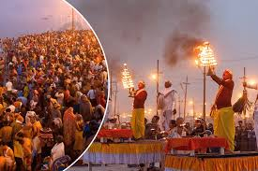

The **Kumbh Mela** is incredibly important for several spiritual, cultural, and religious reasons, making it one of the largest and most significant events in the world. Here's why it's considered so vital:

### 1. ****Spiritual Significance****:

* **Purification of Sins**: According to Hindu belief, bathing in the sacred rivers during the Kumbh Mela cleanses one's soul and absolves sins. The event is based on the myth of the "amrit" (nectar of immortality) that was spilled in the four locations during the churning of the ocean (Samudra Manthan). Bathing in these rivers during the Mela is thought to purify the soul and grant salvation or **moksha**.
* **Connection to Divine Power**: The Kumbh Mela is held when the planets align in such a way that it is believed to be an auspicious time for connecting with divine forces. The alignment of **Jupiter, the Sun, and the Moon** enhances the spiritual energy of the event, making it a powerful time for inner transformation and devotion.

### 2. ****Unity in Diversity****:

* The Kumbh Mela brings together millions of people from all walks of life, from across India and even from around the world. Despite the diversity of languages, cultures, and social classes, the Mela fosters a sense of unity among participants. People from different religious, regional, and cultural backgrounds come together in the spirit of devotion.
* It's a demonstration of the power of faith, where individuals, regardless of their differences, converge for a common spiritual purpose.

### 3. ****Naga Sadhus and Ascetic Traditions****:

* The presence of **Naga Sadhus** (ascetic monks) at the Kumbh Mela adds to its mystique and significance. These Sadhus are known for their extreme forms of renunciation and spiritual practices, and their participation in the Mela symbolizes the highest form of detachment from worldly possessions and the pursuit of spiritual enlightenment.
* Their processions and rituals are deeply symbolic, highlighting the ideals of asceticism and devotion in Hinduism.

### 4. ****Astrological Importance****:

* The Kumbh Mela is scheduled based on specific planetary alignments that are considered to hold great astrological power. According to Hindu astrology, the position of **Jupiter, the Sun, and the Moon** during the Mela's timing creates a celestial opportunity for personal and spiritual growth.
* The precise timings are believed to make the event a once-in-a-lifetime opportunity for spiritual growth and cleansing. The gathering at the "confluence" of sacred rivers (especially the **Sangam** in Prayagraj) is thought to be an ideal place for aligning oneself with cosmic energies.

### 5. ****Cultural and Social Unity****:

* The Kumbh Mela is not only a spiritual event but also a cultural festival. It’s a time for people to showcase their rituals, traditions, folk music, dances, and spiritual discourses, providing a rich cultural tapestry.
* It also brings people together to engage in social service and charitable acts. Many pilgrims volunteer in activities such as food distribution, healthcare, and assisting fellow devotees, creating a sense of community and collective welfare.

### 6. ****Witnessing Miracles and Divine Interventions****:

* Devotees believe that at the Kumbh Mela, miracles can happen. Many believe that participating in the Mela can lead to miraculous healing or even visions of divine figures. The faith and devotion during this event often lead people to experience intense emotional and spiritual transformations.

### 7. ****Global Recognition and Impact****:

* The sheer scale of the Kumbh Mela — with millions of people gathering in one place — attracts attention worldwide. It serves as a symbol of India's rich religious heritage, demonstrating the deep spiritual traditions that have existed for thousands of years.
* The event is also a major boost for the local economy of the host cities, as pilgrims, tourists, and vendors flood the areas during the festival. It creates a sense of international dialogue, as visitors from different countries come to experience the cultural and spiritual practices first-hand.

**How crowd management by government**

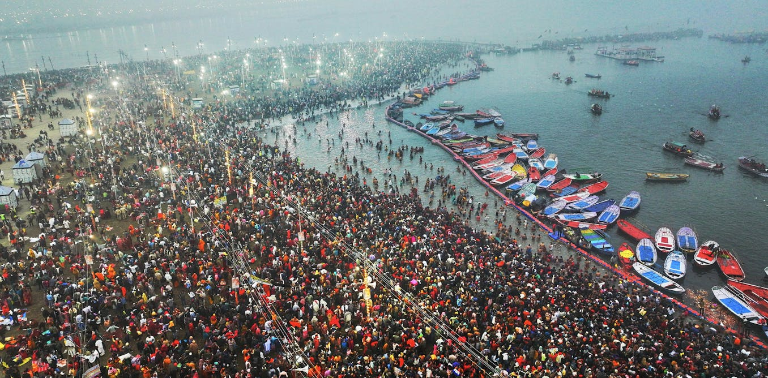

**Crowd management** at the **Kumbh Mela** is a monumental task due to the sheer size of the gathering, often reaching millions of people. The Indian government and local authorities implement a comprehensive, multi-layered strategy to ensure the safety, security, and well-being of all attendees. Here are the main measures taken to manage the crowd effectively:

### 1. ****Planning and Infrastructure Development****:

* **Temporary Infrastructure**: The government sets up a massive **temporary city** around the main site of the Mela, including roads, bridges, toilets, and tents for accommodation. This infrastructure is designed to handle millions of people at once, ensuring ease of movement and basic amenities.
* **Road and Transport Planning**: Roads around the Mela are often widened, and additional routes are planned for the event. Special **bus and train services** are arranged to transport people to and from the site efficiently. Authorities may also issue traffic diversions or close certain routes to streamline the movement of the crowd.

### 2. ****Deployment of Security Forces****:

* **Large-Scale Security**: Thousands of police officers, paramilitary forces, and local security personnel are deployed to maintain order. This includes **crowd control units**, **riot police**, and **volunteers** who assist in keeping the event organized.
* **Surveillance Systems**: CCTV cameras are installed at strategic points to monitor the crowd and ensure that no untoward incidents occur. There are also **drone surveillance** and **face recognition technology** used to monitor people and detect any potential threats.
* **Naga Sadhu and VIP Security**: Special arrangements are made for the protection of religious leaders, Naga Sadhus, and VIPs who participate in the event, ensuring their safety while maintaining the larger flow of crowds.

### 3. ****Crowd Flow Management****:

* **Dividing the Crowd**: The Kumbh Mela site is divided into **sectors or zones** to reduce congestion. Specific entry and exit points are designated for different groups of people, and **clear signage** is used to guide pilgrims to their destinations, such as bathing ghats or other ritual locations.
* **Time-Specific Bathing Slots**: Bathing in the river is a major activity, especially on auspicious days (like **Maha Snan**). To prevent overcrowding, pilgrims are often assigned specific time slots or channels for bathing. This reduces the risk of bottlenecks and ensures a smooth flow of people.
* **Floating Crowd Control**: To ensure people don’t get stuck in large, immovable groups, the police and security personnel often work in a manner that ensures a steady, flowing movement of people rather than sudden bottlenecks. They may direct people using flags, loudspeakers, or hand signals.

### 4. ****Health and Medical Services****:

* **Medical Camps**: Health services are available throughout the Mela site. There are many **medical camps**, including emergency units with paramedics, hospitals, and mobile health units, to deal with any health emergencies.
* **Ambulance and Evacuation Plans**: Ambulances are strategically placed at different spots, and evacuation routes are mapped out to handle medical emergencies. The government ensures there are adequate facilities for the treatment of heat strokes, dehydration, and other health issues, which are common due to the large crowds.

### 5. ****Disaster Management and Contingency Planning****:

* **Emergency Plans**: Detailed plans for natural disasters like floods, stampedes, or accidents are put in place. **Risk management teams** are ready to handle any unforeseen circumstances, such as a sudden rise in river levels or a medical crisis.
* **Safety Protocols**: Safety measures, such as **fire safety drills** and **search-and-rescue teams**, are practiced before the Mela. All security personnel are trained in emergency response.

### 6. ****Use of Technology****:

* **Digital Platforms for Registration**: Pilgrims are often encouraged to register online before attending the event, so authorities can track attendance and keep records of visitors. This also helps in ensuring safety and emergency response efforts.
* **Mobile Apps**: The government may launch official Kumbh Mela apps that provide information about transportation, schedules, health services, lost-and-found centers, and emergency contacts. These apps make it easier for visitors to navigate the event.
* **Wi-Fi Hotspots**: To manage communication during such a large event, Wi-Fi hotspots may be set up in key areas, allowing attendees to stay connected, find directions, or report issues if needed.

### 7. ****Distributing Information****:

* **Public Announcements**: Loudspeakers and digital screens are placed throughout the Mela site to provide important information, such as changes in schedules, emergency alerts, and crowd flow instructions.
* **Helpline Numbers**: Dedicated helplines are set up for lost individuals, medical assistance, and emergency situations. **Lost-and-found counters** are also operational to reunite people who might get separated in the crowd.

### 8. ****Volunteer Support****:

* Thousands of volunteers are mobilized to assist with crowd management, provide information, and offer assistance to pilgrims who need help navigating the site or finding medical help. They play a critical role in ensuring smooth functioning and guiding people through various areas.

### 9. ****Controlled Access to Sacred Bathing Ghats****:

* During peak bathing times, such as the **Maha Snan** (grand bathing day), the authorities take extra precautions by creating **one-way routes**, limiting access to specific ghats, and ensuring that there’s enough space for people to bathe safely without overcrowding. Some ghats may be divided into sections with strict entry points to maintain order.

### 10. ****Waste Management and Cleanliness****:

* Proper waste disposal and cleanliness are key concerns in such a large event. Large numbers of toilets and sanitary facilities are installed, and teams are deployed to ensure the area remains clean.
* **Garbage collection** and **sanitation drives** are organized to manage the large volume of waste generated by the attendees.

### 11. ****Traffic Management****:

* Given the huge influx of pilgrims, special **traffic control measures** are implemented to regulate the flow of vehicles into and out of the area. This includes arranging temporary parking lots and coordinating with **local transport agencies** to shuttle people safely to the Mela site.
* **Pedestrian paths** are carefully planned to ensure the safety of pilgrims walking to the event, especially when approaching the sacred bathing ghats.

In summary, crowd management at the Kumbh Mela is a massive logistical undertaking that involves extensive planning, resource allocation, and coordination between multiple government agencies, security forces, and volunteers. The primary goal is to ensure the safety, security, and comfort of the pilgrims while maintaining the sanctity and spiritual significance of the event.

**What is the impact**

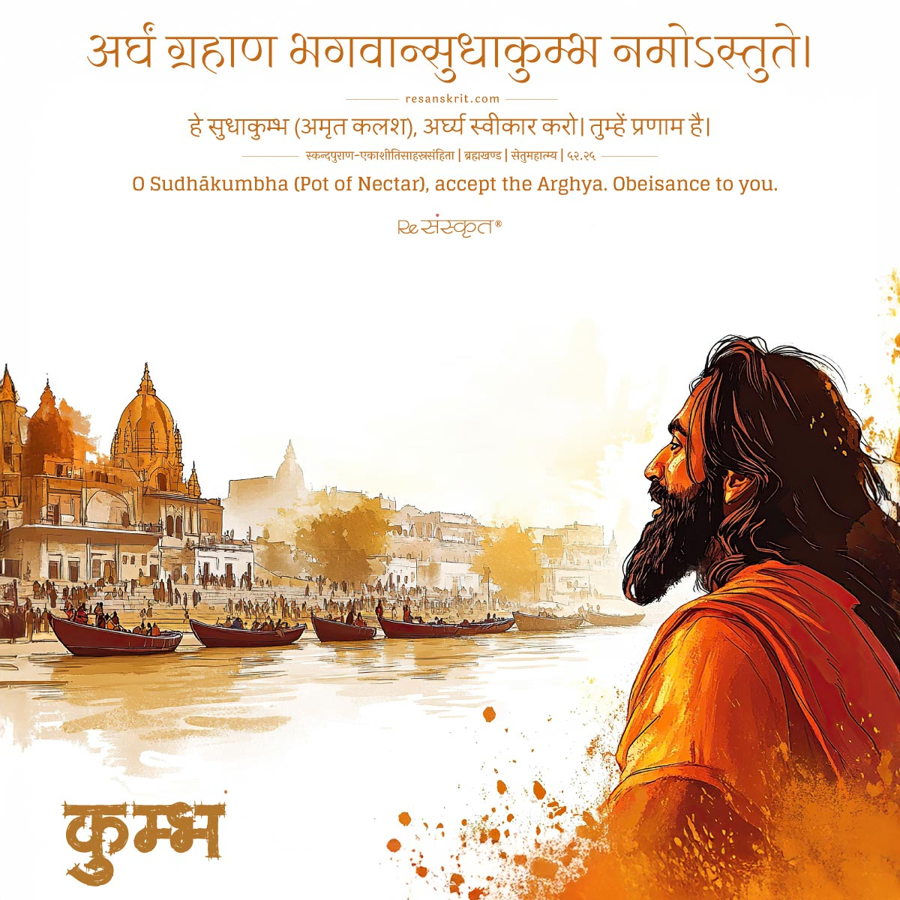

The **Kumbh Mela** has a profound impact both within **India** and **globally**. It is not just a religious or cultural event but also a social, economic, and international phenomenon with far-reaching consequences. Here are the impacts of the Kumbh Mela on both **India** and **countries outside of India**:

### ****Impact Within India****:

#### 1. **Cultural and Religious Unity**:

* The Kumbh Mela is a **unifying force** that brings people from diverse backgrounds, regions, and communities together. It is a shared expression of faith, where millions of Hindus (and non-Hindus) participate in rituals and seek spiritual renewal.
* It celebrates India's **religious diversity**, where people from different parts of the country, and from different sects, come together under one umbrella of devotion.

#### 2. **Promoting Religious Tourism**:

* The Kumbh Mela is one of the largest **religious tourism events** in the world. Every 12 years, it draws millions of pilgrims and visitors to the host cities (Prayagraj, Haridwar, Nashik, Ujjain). These cities experience a surge in **tourism**, with pilgrims contributing to the local economy through **travel, accommodation, food, and services**.
* The event significantly boosts the **local economy**, especially for vendors, hotels, transportation, and other service providers.

#### 3. **Economic Impact**:

* The **Kumbh Mela** generates **billions of rupees** in revenue for the local economy, including the hospitality sector, transportation, food vendors, and even small businesses. For example, shopkeepers, restaurant owners, and taxi drivers benefit from the influx of people.
* Temporary businesses also emerge, selling religious items, crafts, souvenirs, and spiritual literature, creating jobs and fostering small-scale enterprises.

#### 4. **Development and Infrastructure**:

* The **infrastructure development** required to host the Kumbh Mela often results in long-term improvements in the host cities. For example, better roads, sanitation systems, and public transport are put in place, benefiting the residents even after the event is over.
* The government invests in creating **temporary infrastructure** like roads, toilets, bridges, healthcare facilities, and security measures, many of which remain useful for the city even after the Mela ends.

#### 5. **Environmental Awareness**:

* The large number of people who converge at the Kumbh Mela leads to increased **environmental awareness** in terms of waste management, cleanliness, and the need for conservation. There is usually a focus on **sustainable practices**, including **water management** and reducing pollution in the rivers, particularly the Ganges.
* Initiatives like **plastic-free zones**, **eco-friendly camps**, and **waste segregation** are implemented to minimize the environmental impact of such a large gathering.

#### 6. **Social Cohesion**:

* Kumbh Mela fosters **social harmony**. It transcends barriers of caste, creed, language, and region, creating a sense of **national identity**. Pilgrims, volunteers, and local residents work together, share meals, and engage in spiritual activities, helping bridge social gaps.

### ****Impact Outside of India****:

#### 1. **Global Recognition of Indian Culture**:

* The Kumbh Mela brings global attention to **India's religious and spiritual heritage**. Through media coverage and the involvement of foreign tourists, the Mela showcases India's **rich spiritual traditions**, art, rituals, and diverse cultures.
* The Kumbh Mela highlights Hinduism's vast traditions of pilgrimage, meditation, and devotion, contributing to the **global understanding** of Indian culture and spirituality.

#### 2. **Attraction of International Tourists**:

* Pilgrims and non-pilgrims from around the world travel to India to witness or participate in the Kumbh Mela. The event has become a **cultural spectacle** for international tourists, especially those interested in spirituality, culture, and anthropology.
* The Kumbh Mela is often highlighted in **travel documentaries**, books, and articles, encouraging people worldwide to visit India for this extraordinary spiritual gathering.

#### 3. **Interfaith Dialogue**:

* While primarily a Hindu event, the **Kumbh Mela** has a universal appeal due to its focus on spirituality and purification. People of different faiths, including Christians, Muslims, Sikhs, and Buddhists, visit the event to witness the religious practices, rituals, and the spirit of unity.
* This creates an opportunity for **interfaith dialogue** and understanding, as the Mela becomes a point of commonality for those exploring the human quest for spiritual awakening and inner peace.

#### 4. **Diplomatic and International Relations**:

* The Kumbh Mela is sometimes attended by **foreign dignitaries** and diplomats. The event fosters **cultural diplomacy**, strengthening ties between India and other countries, especially those with large Indian diaspora communities.
* The event also promotes **tourism and soft power** for India on the international stage. It allows the world to witness India’s unique spiritual culture, leading to greater cultural exchange and global recognition of Indian traditions.

#### 5. **Inspiring Global Movements**:

* The scale of the Kumbh Mela and its religious and cultural significance has inspired similar events and pilgrimages in other parts of the world. For example, large-scale festivals or spiritual gatherings like those in **Nepal** or among Indian diaspora communities abroad often look to the Kumbh Mela as a model.
* The environmental and social initiatives seen in the Kumbh Mela are also often shared globally, inspiring people worldwide to think about sustainability, spirituality, and collective social responsibility.